PULLEYS

Pulleys are useful for lifting loads vertically. They work by changing the direction of the force.

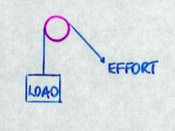
One Pulley

The load will move the same distance as the effort.

∴ No force advantage.

e.g. If the load is 300 N, the effort is 300 N.

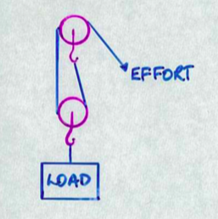
Two Pulleys

Since the load is held by two ropes, the distance moved by the effort is twice the distance moved by the load.

∴ Have a distance disadvantage but a force advantage.

e.g. If the load is 300 N, the effort is 150 N.

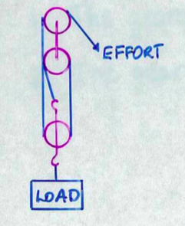
Three Pulleys

Three ropes support the load, so the effort moves three times the distance of the load.

∴ Have a distance disadvantage but a force advantage.

e.g. If the load is 300 N, the effort is 100 N.

Pulleys can be set up to gain a distance advantage - the driving pulley is large while the second pulley is small. Both are connected by a belt of some type.

e.g. Used in wood and metal lathes to turn pieces at high speed.

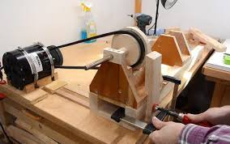

A small driving wheel will give a force advantage and distance disadvantage.

e.g. Used in a concrete mixer to turn it slowly.

